
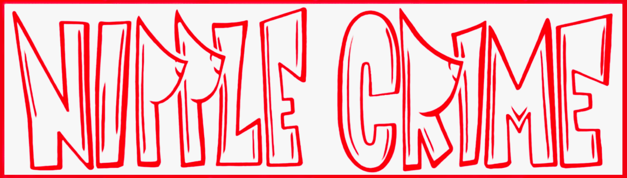

STANDARD OPERATING PROCEDURE
HubSpot

SOP Number | Com3 | Department | Communications
Version | 1.0 | Effective Date | 2026-03-03
Last Updated: 2026-03-03

1. Purpose
This SOP covers how Nipple Crime uses HubSpot for contact management, forms, email marketing (Nipple News), and website upkeep. HubSpot is the central CRM and outbound communications platform managed by the Communications Officer.

2. Access & Permissions
Before doing anything else, verify you have the correct permissions.
- Minimum required: Super Admin (or equivalent) access
- Required access areas:
- CRM (Contacts)
- Marketing > Forms
- Marketing > Email
- Content / Website Pages
- Commerce (optional; usually Treasurer-owned)
- To check: Settings > Users & Teams in HubSpot
- If you cannot create/edit properties, lists, or forms -- fix permissions before troubleshooting anything else
- Note: Property-level access can be restricted separately from general contact access

3. Data Model
- Every person is a Contact record
- Contact properties store structured answers (e.g., 'Interested in camp 2026?', 'Volunteer hours', 'Leadership role')
- Forms collect and update properties at scale
- Lists/Segments (active or static) target the right people for outreach

4. Naming Conventions
Use consistent naming so properties and lists stay organized across years.

PROPERTIES (prefix with year):
- 2026 - Interested in Camp
- 2026 - Volunteer Time Available
- 2026 - Leadership Interest
- 2026 - Leadership Role (Assigned)

LISTS/SEGMENTS:
- 2026 - Interest: Yes/Maybe/Unknown
- 2026 - Interest: No
- 2026 - Potential Leaders (Interested, No Role Assigned)
- 2026 - Needs Follow-up (No response yet)

List type rule:
- Active lists: anything ongoing (auto-updates as responses come in)
- Static lists: one-time snapshots (everyone invited to X at time of send)

5. Create a Contact Property
Use this to add a structured field (e.g., a dropdown) for survey answers.

- In HubSpot, click Settings (gear icon)
- Go to Data Management > Properties
- Choose object type: Contact
- Click Create Property
- Set:
- Property label: e.g., 2026 - Interested in Camp
- Field type: Dropdown select
- Options: Yes, Maybe, No
- Save

The property is now available in forms, contact views, and list filters.
Troubleshooting: If 'Create property' is missing or throws errors, check Super Admin permissions.

6. Build the Annual Interest / Labor / Leadership Form
Clone last year's form rather than building from scratch.

- Go to Marketing > Forms
- Find last year's 'Existing Member Interest' form
- Clone it
- Update text to 2026; keep it short
- Required fields:
- Email (required)
- 2026 - Interested in Camp (dropdown: Yes / Maybe / No)
- 2026 - Volunteer Time Available (dropdown)
- 2026 - Leadership Interest (dropdown)
- Recommended dropdown options for Volunteer Time Available:
- 1-2 hours/week
- 3-4 hours/week
- 4+ hours/week
- I have time mainly close to the burn
- No time / can't help this year
- Recommended dropdown options for Leadership Interest:
- Yes -- I'm interested in a leadership role
- Maybe -- talk to me
- No -- not this year
- Publish the form
- Get the share link: Marketing > Forms > hover form > Actions > Share > Copy link
- Quality check: submit it yourself once and confirm the properties updated on your contact record

7. Create a Segment / List for Targeting
- Go to CRM > Lists (Segments)
- Create a Contact-based list
- Choose list type (Active or Static -- see Section 4)
- Build filters

EXAMPLE A: '2026 - Interest: Yes/Maybe/Unknown' (Active list)
Filter: 2026 - Interested in Camp is any of: Yes, Maybe
(and/or is unknown/empty for non-responders)

EXAMPLE B: 'Potential Leaders (Willing + No Role Assigned)'
Prereq: create '2026 - Leadership Role (Assigned)' property first
Filter 1: 2026 - Leadership Interest is any of: Yes, Maybe
Filter 2: AND 2026 - Leadership Role (Assigned) is unknown/empty
Save as: '2026 - Potential Leaders (No Role Assigned)'

8. Send Nipple News Email
Clone last year's closest matching email rather than building from scratch.

- Go to Marketing > Email
- Find last year's matching email (e.g., 'Are you coming?')
- Clone
- Edit: subject line (clear + action-oriented), body (short sections, bold deadlines), insert form link
- Preview as a real contact; send a test email to yourself
- Set Send to list: '2026 - Interest: Yes/Maybe/Unknown'
- Enable web version ('view in browser') so you can share the link on Facebook or via SMS
- Send

WEB VERSION SHARE TEMPLATE (SMS/Facebook):
Nipple News #1 is out -- full details here: [WEB VERSION LINK]

9. Get the Web Version Link
- Open the email in HubSpot
- Go to email details / web version area
- Copy the web version URL
Use this link for: Facebook group posts, SMS 'read more' links, members who don't read email.

10. Website Upkeep (HubSpot CMS)
Keep Sign Up, Donate, and other key pages current each year.

- Go to Content > Website Pages
- Click the page to edit
- Update text, dates, and buttons
- Publish (or schedule publish)

If temporarily disabling a button (e.g., donations not open yet):
- Remove the button URL, OR
- Change the button URL to the homepage to avoid a dead link

11. Payment Links (Know Where They Live)
Payment links are owned by the Treasurer but Comms touches them when updating pages or emails.
Location: HubSpot > Commerce > Payment Links

Comms responsibilities:
- Update broken or mislabeled buttons on web pages (notify Treasurer when doing so)
- Do NOT change pricing or payment plan logic without explicit Treasurer approval

12. Handoff Checklist (for Next Comms Officer)
Keep this updated throughout the year so handoff is smooth.

- List of active properties created this year (names + purpose)
- List/segment names used
- Which form is the canonical interest form for this year
- Message templates:
- First interest SMS
- Leadership recruitment SMS
- Nipple News email skeleton
- Where web version links live (and how to generate them)
- Website pages most often updated (Sign Up, Donate, etc.)
- Who to contact for permissions: President / Super Admin

13. Contacts
- Communications Officer (HubSpot owner): Daemon Wyner
- President (approves major messaging + payment decisions): Reece Dassinger
- Treasurer (payment links, dues language): Isabel Hoy
- VP / SOP Owner: Chris Reddin

14. Revision History
- v1.0 | 2026-03-03 | Initial draft | Chris Reddin

